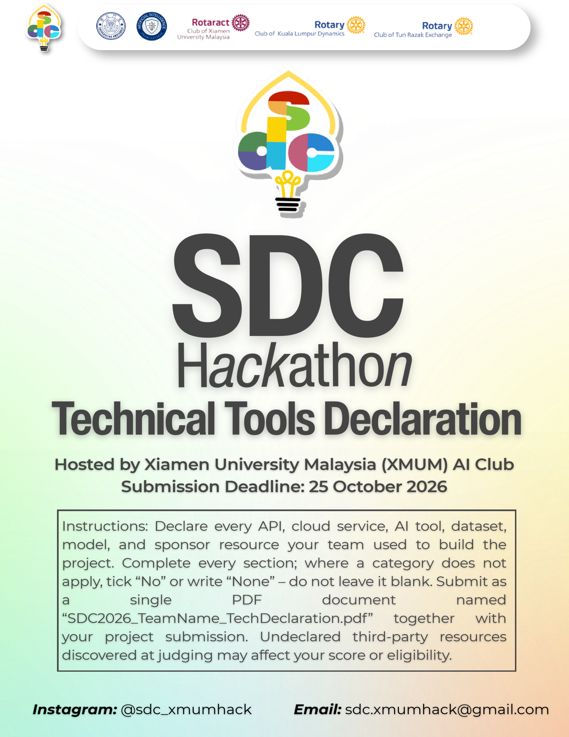
SDC HACKATHON 2026
Technical & Tools Declaration
Hosted by Xiamen University Malaysia (XMUM) AI Club
Submission Deadline: [Insert date]
Instructions: Declare every API, cloud service, AI tool, dataset, model, and sponsor resource your team used to build the project. Complete every section; where a category does not apply, tick “No” or write “None” – do not leave it blank. Submit as a single PDF document named “SDC2026_TeamName_TechDeclaration.pdf” together with your project submission. Undeclared third-party resources discovered at judging may affect your score or eligibility.

1. Team & Project Overview
Team Name | XYZQ Labs
Project / Solution Name | Future Ready
Name (Leader) | Yi Hongyu
Email & Phone (Leader) | eng2409018@xmu.edu.my
University Affiliation(s) | Xiamen University Malaysia
Live Prototype URL | https://future-ready-demo.onrender.com/
Code Repository URL (public / access granted to judges) | https://github.com/Honray-Yi/SDG_FutureReady_employment_website

2. Architecture & Technology Stack

2.1 System Architecture Overview
Describe how the components declared in this document connect end-to-end (e.g., user interface → backend → AI model/API → database → cloud hosting). Attach a system block diagram as an appendix if available.
[Maximum 200 words]
The bilingual React and TypeScript frontend, built with Vite, collects or displays a skills profile and sends requests to the Python FastAPI backend. The backend matches profile information against the project’s versioned JSON/CSV role, skill, trend, course, scenario, and SDG data. In the full local résumé workflow, reviewed text is embedded by a pinned, quantized ONNX version of the pre-trained multilingual E5 model, and cosine similarity is used to rank roles and identify skill gaps. The public Render demo uses synthetic profiles and does not run the full résumé model workflow. The application does not call a generative-AI API for runtime matching and does not use a SQL database. Render hosts the synthetic-profile demo; GitHub Actions runs repository checks. Data-refresh and model-setup scripts can access public external sources, but those calls are not made for each user request.

2.2 Languages, Frameworks & Libraries
List the main programming languages, frameworks, and third-party libraries that your team did not create. Open-source use is permitted provided it is declared and properly licensed/attributed.
Name & Version | Purpose in Project | License
React 19.1.0 | Frontend UI | MIT
TypeScript 5.9.3 | Frontend and shared type checking | Apache-2.0
Vite 7.3.7 | Frontend build and development server | MIT
Python 3.13 | Backend and data utilities | PSF License
FastAPI 0.162.0 | Backend API | MIT
Uvicorn 0.54.0 | ASGI server | BSD-3-Clause
NumPy 2.5.4 | Numerical operations | BSD-3-Clause
ONNX Runtime 1.31.0 | Local model inference | MIT
Tokenizers 0.23.3 | Text tokenization for the embedding model | Apache-2.0
pypdf 6.21.2 | Text extraction from PDF files | BSD-3-Clause

3. APIs & Cloud Services

3.1 External APIs
List every external API your solution calls (GenAI, maps, payments, messaging, data feeds, etc.). Do not include API keys or secrets in this document.
API & Provider | Purpose in Project | Access Tier
Arbeitnow Job Board API | Optional/manual refresh of public job-posting snapshots; not called for each user request | Public API; subject to provider terms
arXiv API | Optional/manual refresh of research metadata and aggregate publication counts; no paper full text is bundled | Public API
Hugging Face Model Hub | Downloads pinned public ONNX model and tokenizer files during local setup only | Public model files
Google Cloud Storage via Replit App Storage | Optional storage and retrieval of model assets when the Replit storage setup is enabled | Replit-provisioned; account plan applies

3.2 Cloud Platforms & Deployment
List every cloud service used for hosting, storage, databases, authentication, or compute, and indicate how the prototype is deployed.
Service & Provider | Purpose in Project | Plan / Region
Render Web Service | Hosts the public synthetic-profile demo | Free plan; Singapore
Replit Workspace | Development and prototyping | Plan/region not recorded in the repository
Replit App Storage / Google Cloud Storage | Optional storage for public model assets; not for résumé storage | Used only when configured; plan depends on Replit account
GitHub Actions | Repository CI checks | GitHub-hosted runners; account quota/plan applies

4. AI Tools, Models & Datasets

4.1 AI Models Used in the Solution
List every AI model embedded in or called by your application, including pre-trained, fine-tuned, and self-trained models.
Model & Version | Source / Provider | Usage | License / Terms
intfloat/multilingual-e5-small; quantized ONNX assets from Xenova/multilingual-e5-small, pinned revision 761b726dd34fb83930e26aab4e9ac3899aa1fa78 | intfloat / Xenova on Hugging Face | Pre-trained; used for local text embeddings and résumé-to-role similarity matching; not fine-tuned | MIT; asset hashes and revision are documented in docs/model-notice.md

4.2 Datasets
List all datasets used for training, fine-tuning, evaluation, or in the running application. State clearly if a dataset contains personal or sensitive data.
Dataset Name | Source / URL | Type | License | Personal Data?
Role and skill catalogues, including roles, skill dictionary, and taxonomy crosswalk | Project data package; sources include O*NET, BLS, MASCO, and MYCOL. See artifacts/api-server/data-package/ATTRIBUTION_AND_USE.md | Curated/derived public-source data | Source-specific terms; the 65-role catalogue’s upstream redistribution terms still need confirmation | No
Job-market snapshots and trend signals | Arbeitnow Job Board API, plus project calculations | Public snapshots and derived indicators | Provider terms apply; preserve source attribution and listing URLs | No applicant data; job-posting content only
Research counts and metadata | arXiv API | Public metadata and aggregate counts | arXiv API terms; paper licenses vary; no full papers included | No
Malaysia labour-force skills-related underemployment data | data.gov.my / Department of Statistics Malaysia | Public, aggregated data | CC BY 4.0, as recorded in the project attribution file | No
Occupation outlook and Malaysia occupational context | BLS, DOSM/data.gov.my, MASCO, and TalentCorp MYCOL; see project attribution file | Public-source facts and curated mappings | Source-specific terms; attribution required | No
Courses and local programmes | Course providers and HRD Corp e-LATiH directory | Public programme metadata and links | Provider terms apply; course content is not bundled | No
Scenario and SDG mappings | Project-authored scenarios; UN SDG targets | Self-authored heuristics and public reference text | Project code/data terms and UN source attribution | No
Synthetic demo profiles | Created for this project | Synthetic | Project-authored; no real person records | No

4.3 AI-Assisted Development Tools
Tools used to help write code, design, content, or documentation (e.g., chat assistants, code completion tools, image generators). Declaring these tools does not reduce your score; undeclared use may.
Did your team use any generative-AI tool to help create code, design, text, or other project material?
☐ Yes ☐ No
If yes, list them below:
Tool & Version | Used For | Extent of Use
OpenAI ChatGPT and Codex; model/version varied by session and was not consistently recorded | Code changes, debugging, interface and documentation work, PRD, pitch deck, and submission drafts | Moderate

Briefly describe how your team reviewed, tested, and took responsibility for AI-generated output:
[Maximum 100 words]
The team reviewed AI-assisted code and writing against the project requirements, repository behavior, and cited sources. Code changes were checked through the project’s build, type-checking, API/core-flow tests, and repository CI as applicable. Factual claims and third-party attributions were checked against project records and source documentation. The team remains responsible for reviewing and correcting submitted material. AI-generated output is not treated as evidence of employment outcomes or measured social impact.

5. Sponsor-Provided Resources
Declare any official SDC sponsor-provided GenAI API, cloud credits, tools, mentoring, or data that your team used.
Did your project use any official SDC sponsor-provided resource?
☐ Yes ☐ No
If yes, list them below:
Sponsor | Resource (API / credits / platform / data) | How It Was Used in the Project
Replit | credits | Vibe coding
RunPod | GPU API | More computational powers, faster speed

Was the sponsor resource essential to the core functionality of the prototype, or could it be replaced? Explain briefly:
[Maximum 100 words]
The sponsor resources were not essential to the prototype’s core functionality. Replit was used for development and prototyping, but the application can run in another compatible environment and is deployed on Render. RunPod was not used for this prototype. The full local résumé-matching workflow uses CPU-based ONNX inference, while the hosted demo uses synthetic profiles. Therefore, neither Replit nor RunPod is required for the core user experience.

6. Security, Privacy & Responsible Use

6.1 Data Handling & Privacy
What user or personal data does your application collect, store, or send to third-party services (including AI APIs)? How is it protected, and how long is it kept? State “No user data is collected” if applicable.
[Maximum 150 words]
The public hosted demo is intended for synthetic profiles; users should not upload real résumés to it. In a properly provisioned local deployment, a user may provide résumé text or a text-based PDF/DOCX. The backend extracts and processes that text locally for matching after review and confirmation. The application is designed not to save résumé files, extracted text, or embeddings as persistent user history. Runtime résumé matching does not send user text to an external GenAI service. Optional Replit App Storage is used only for model assets, not résumé data. The project’s packaged public datasets contain no applicant records or sensitive personal data.

6.2 Known Limitations & Risks
Identify the main technical limitations of your AI components (e.g., hallucination, bias, rate limits, dependency on a single provider) and any mitigation you have implemented.
[Maximum 150 words]
E5 similarity scores indicate textual similarity, not verified skill proficiency, hiring probability, or employment suitability. The model may reflect language and representation biases, and the role catalog may not fully represent local occupations or changing employer requirements. Job and research snapshots can become stale; some job-market evidence is Europe-oriented, so it should not be treated as a Malaysia-wide forecast. Moderate and fast-disruption scenarios are heuristic comparisons, not calibrated predictions. Mitigations include showing data sources and dates, allowing users to review and confirm profile information, keeping a human in control of career decisions, labeling scores and scenarios as estimates, using synthetic profiles in the public demo, and checking pinned model assets by hash. The full résumé workflow also requires local model assets and sufficient memory.

7. Compliance & Readiness Checklist
Tick all boxes that apply before submitting.
☐ | All APIs, cloud services, AI tools, models, and datasets used in the project are declared in this document.
☐ | All third-party code, datasets, and models are used in accordance with their licenses, and attribution is provided where required.
☐ | No API keys, passwords, or other credentials are exposed in the code repository, prototype, or this document.
☐ | Any use of generative-AI tools for development has been disclosed and reviewed by the team.
☐ | Any use of official SDC sponsor resources has been declared in Section 5.
☐ | The prototype described here is accessible to judges through the links provided in Section 1.
☐ | All fields in this template have been completed within the word limits stated.

8. Declaration
By submitting this document, the team leader confirms that the information provided is complete and accurate to the best of the team’s knowledge, and that every API, cloud service, AI tool, dataset, model, and sponsor resource used in the project has been declared.
[Signature]
[Date]25/10/2026

